

**INTERNATIONAL SCHOOL**

**CAPSTONE PROJECT 1**

**CMU-SE 450**

**USER INTERFACE DESIGN DOCUMENT**

Version: 1.1

**FOOD MANAGEMENT SYSTEM – FMS**

**Mentor: Nguyen Dang Quang Huy**

***Team Member*:**

Nhan, Tran Van

Tuan, Phan Tuan

Huy, Huynh Duc

Huy, Chau Ngoc

**Approved by Huy Nguyen Dang Quang**

**UserInterface Review Panel Representative:**

Name Signature Date

**Capstone Project 1- Mentor:**

Name Signature Date

Da Nang, 10/2022

**PROJECT INFORMATION**

|  |  |
| --- | --- |
| **Project Acronym** | FMS |
| **Project Title** | Food Management System | | | |
| **Start Date** | 17 – Aug –2022 | **End Date** | 12 – Dec –2022 | |
| **Lead Institution** | International School, Duy Tan University | | | |
| **Team Member** | **Name** | **Email** | | **Phone** |
| 25211215742 | Tran Van Nhan | tranvannhan2362001@gmail.com | | 0772015981 |
| 25211205729 | Phan Anh Tuan | tuanphan0903@gmail.com | | 0903533084 |
| 25211216010 | Huynh Duc Huy | huy77001@gmail.com | | 0835650230 |
| 25211208040 | Chau Ngoc Huy | chaungochuy0801@gmail.com | | 0905293654 |

**PROJECT PLAN DOCUMENT**

|  |  |  |  |
| --- | --- | --- | --- |
| **Document Title** | User Interface Document | | |
| **Author(s)** | C1SE.28 Team | | |
| **Date** | Sep 29th, 2022 | **File name:** | C1SE.28_FMS_ProjectPlan_v1.1.docx |
| **URL** | https://drive.google.com/drive/u/0/folders/1dF29KwsuPN5xl7slOI3nQmHSa5mHnn3B | | |
| **Access** | Project and CMU Program | | |

**SIGNATURE**

**Document Approvals:** The following signatures are required for approval of this document.

|  |  |  |  |
| --- | --- | --- | --- |
| **Mentor** | Huy, Nguyen Dang Quang | **Signature:** |  |
| **Date:** |  |
| **Scrum master** | Nhan, Tran Van | **Signature:** |  |
| **Date:** |  |
| **Team member(s)** | Tuan, Phan Anh | **Signature:** |  |
| **Date:** |  |
| Huy, Huynh Duc | **Signature:** |  |
| **Date:** |  |
| Huy, Chau Ngoc | **Signature:** |  |
| **Date:** |  |

**DOCUMENT HISTORY**

|  |  |  |  |
| --- | --- | --- | --- |
| **Version** | **Person** | **Date** | **Description** |
| 1.0 | Chau Ngoc Huy | Oct 23th, 2020 | Draft |
| 1.1 | Chau Ngoc Huy | Nov 18th, 2022 | Update |

TABLE OF CONTENTS

I. INTRODUCTION 6

**1. PURPOSE 6**

**2. SCOPE 6**

II. LIST OF USER INTERFACE 7

**1. BUSINESS FUNCTION DIAGRAM: 7**

**2. WEB APP: 8**

III. DESCRIBE USER INTERFACE 12

**1. LOGIN PAGE 12**

**2. ADMIN 13**

**2.1 PAGE MANAGE ACCOUNTS 13**

**2.2 PAGE ADD ACCOUNT 14**

**2.3 UPDATE ACCOUNT PAGE 15**

**2.4 MANAGE EMPLOYEE PAGE 16**

**2.5 ADD EMPLOYEE PAGE 17**

**2.6 UPDATE EMPLOYEE PAGE 18**

**2.7 MANAGE DEPARTMENT PAGE 19**

**2.8 ADD DEPARTMENT PAGE 20**

**2.9 UPDATE DEPARTMENT PAGE 21**

**2.10 LIST EMPLOYEE IN DEPARTMENT PAGE 22**

**2.11 MANAGE FACE PATTERN PAGE 22**

**2.12 MANAGE PROFILE PAGE 23**

**2.13 MANAGE WORKSHITFT PAGE 24**

**2.14 CREAT SHIFT PAGE 25**

**2.15 UPDATE SHIFT PAGE 26**

**2.16 MORE SHIFT PAGE 27**

**2.17 CHANGE SHIFTS PAGE 28**

**2.18 TIMEKEEPING PAGE 29**

**2.19 REPORT STATISTICS PAGE 30**

**2.20 ORDER PAGE 30**

**2.21 ORDER CONFIRM PAGE 31**

**2.22 PERSONAL PROFILE PAGE 32**

**2.23 MANAGER MENU PAGE 33**

**2.24 ADD FOOD PAGE 34**

**2.25 MANAGE SUPPLIER 35**

**2.26 ADD SUPPLIER PAGE 36**

**2.27 UPDATE SUPPLIER PAGE 37**

**2.28 MANAGER MATERIAL PAGE 38**

**2.29 ADD MATERIAL PAGE 39**

**2.30 UPDATE MATERIAL PAGE 40**

**2.31 VIEW REGISTRATION PAGE 41**

**3. MANAGEMENT 42**

**3.1 MANAGE PROFILE PAGE 42**

**3.2 MANAGE WORKSHITFT PAGE 43**

**3.3 CREAT SHIFT PAGE 44**

**3.4 UPDATE SHIFT PAGE 45**

**3.5 MORE SHIFT PAGE 46**

**3.6 CHANGE SHIFTS PAGE 47**

**3.7 TIMEKEEPING PAGE 48**

**3.8 REPORT STATISTICS PAGE 49**

**4. STAFF 49**

**4.1 ORDER PAGE 49**

**4.2 ORDER CONFIRM PAGE 50**

**4.3 PERSONAL PROFILE PAGE 51**

**5.CHEF 52**

**5.1 MANAGER MENU PAGE 52**

**5.2 ADD FOOD PAGE 53**

**5.3 MANAGE SUPPLIER 54**

**5.4 ADD SUPPLIER PAGE 55**

**5.5 UPDATE SUPPLIER PAGE 55**

**5.6 MANAGER MATERIAL PAGE 56**

**5.7 ADD MATERIAL PAGE 57**

**5.8 UPDATE MATERIAL PAGE 58**

**5.9 VIEW REGISTRATION PAGE 59**

## 

**TABLES**

**Table 1: List of Interface 8**

**Table 2: Describe User Interface Login page 12**

**Table 3: Describe User Interface Manage Accounts page 13**

**Table 4: Describe User Interface Add Account page 14**

**Table 5: Describe User Update account page 15**

**Table 6: Describe User Manage employee page 16**

**Table 7: Describe User Add employee page 17**

**Table 8: Describe User Interface Update employee page 18**

**Table 9: Describe User Interface Manage Department page 19**

**Table 10: Describe User Interface Add department page 20**

**Table 11: Describe User Interface Update department page 21**

**Table 12: Describe User Interface List employee in department 22**

**Table 13: Describe User Interface Manage face pattern page 22**

**Table 14: Describe User Interface Manage profile page 23**

**Table 15: Describe User Interface Manage workshitft page 24**

**Table 16: Describe User Interface Creat shift page 25**

**Table 17: Describe User Interface Update shift page 26**

**Table 18: Describe User Interface More shift page 27**

**Table 19: Describe User Interface Change shifts page 28**

**Table 20: Describe User Interface Timekeeping page 29**

**Table 21: Describe User Interface Report statistics page 30**

**Table 22: Describe User Interface Order page 30**

**Table 23: Describe User Interface Order confirm page 31**

**Table 24: Describe User Interface Personal profile page 32**

**Table 25: Describe User Interface Manager menu page 33**

**Table 26: Describe User Interface Add food page 34**

**Table 27: Describe User Interface Manage Supplist page 35**

**Table 28: Describe User Interface Add Supplist page 36**

**Table 29: Describe User Interface Update Supplist page 37**

**Table 30: Describe User Interface Manager material page 38**

**Table 31: Describe User Interface Add material page 39**

**Table 32: Describe User Interface Update material page 40**

**Table 33: Describe User Interface View Registration page 41**

**Table 34: Describe User Interface Manage profile page 42**

**Table 35: Describe User Interface Manage workshitft page 43**

**Table 36: Describe User Interface Creat shift page 44**

**Table 37: Describe User Interface Update shift page 45**

**Table 38: Describe User Interface More shift page 46**

**Table 39: Describe User Interface Change shifts page 47**

**Table 40: Describe User Interface Timekeeping page 48**

**Table 41: Describe User Interface Report statistics page 49**

**Table 42: Describe User Interface Order page 49**

**Table 43: Describe User Interface Order confirm page 50**

**Table 44: Describe User Interface Personal profile page 51**

**Table 45: Describe User Interface Manager menu page 52**

**Table 46: Describe User Interface Add food page 53**

**Table 47: Describe User Interface Manage Supplist page 54**

**Table 48: Describe User Interface Add Supplist page 55**

**Table 49: Describe User Interface Update Supplist page 55**

**Table 50: Describe User Interface Manager material page 56**

**Table 51: Describe User Interface Add material page 57**

**Table 52: Describe User Interface Update material page 58**

**Table 53: Describe User Interface View Registration page 59**

# INTRODUCTION

## PURPOSE

* Document the design of user interface of functions of the Food Management
* Be the primary document driving the implementation of the user interfaces.
* Introduce interface design for the reader. Including the background, content information display, command buttons.

## SCOPE

* This document helps to better understand the interface of the System, detailed specification components and function of the System.
* With this document, the development team can understand the structure and composition to create a consistent and complete system.
* Overview of the stages and modules of the software and create a complete interface.

## SCOPE

This document is intended for the following audiences:

* Technical reviewers including:
* Scrum Master
* Product owner
* Implementers, including:
  + Developers.
  + Testers.

# LIST OF USER INTERFACE

## BUSINESS FUNCTION DIAGRAM:

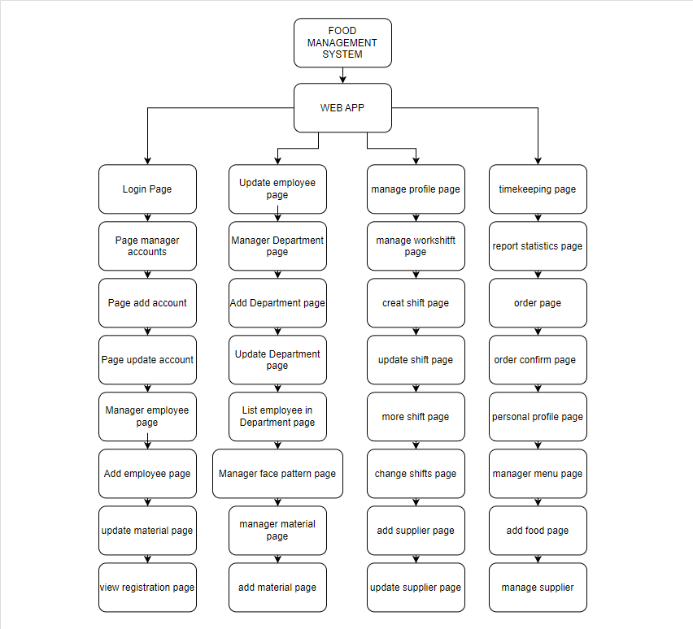

*Figure 1: Business Function diagram*

## WEB APP:

|  |  |  |
| --- | --- | --- |
| **User Interface ID** | **UI Name** | **Description** |
| UI-01 | Login Page | Login will be used as the function to allow user to log into the system, it needs to be put in moderation. |
| UI-02 | Page manage accounts | This page is for admins to manage accounts |
| UI-03 | Page add account | This page is for admins to manage accounts |
| UI-04 | Update account page | This page is for admin to manage account updates |
| UI-05 | Manage employee page | This page is for admin to manage employees |
| UI-06 | Add employee page | This page is for admins to manage add employees |
| UI-07 | Update employee page | This page is for admins to manage update employees |
| UI-08 | Manage department page | This page is for the admin to manage the department |
| UI-09 | Add department page | This page is for admins to add departments |
| UI-10 | Update department page | This page is for admins to update departments |
| UI-11 | List employee in department page | This page is for admin to see the employees in the department |
| UI-12 | Manage face pattern page | This page is for admin to manage face pattern page |
| UI-13 | Manage profile page | This page is for management manage employee profile page |
| UI-14 | Manage work shitft page | This page is for management manage work shitft page |
| UI-15 | Creat shift page | This page to create work shitft for employees |

*Table 1: List of Interface*

# DESCRIBE USER INTERFACE

## LOGIN PAGE

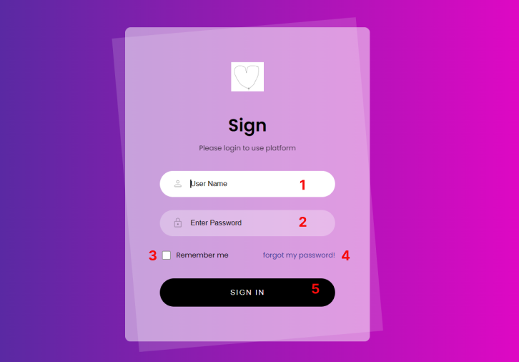

|  |  |  |  |
| --- | --- | --- | --- |
| **ID** | **Condition** | **Control Type** | **Target** |
| 1 | Press | Input text | Enter your username |
| 2 | Press | Input text | Enter password |
| 3 | Press | Checkbox | Click to agree to save the password |
| 4 | Press | Button | Click to go to the forgot my password page |
| 5 | Press | Button | Click to login to the site |

Table 2: Describe User Interface Login page

## ADMIN

### PAGE MANAGE ACCOUNTS

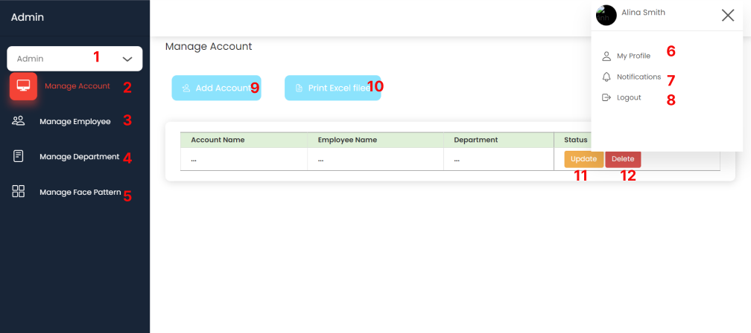

|  |  |  |  |
| --- | --- | --- | --- |
| **ID** | **Condition** | **Control Type** | **Target** |
| 1 | Press | Select, Option | Choose admin, manager, chef, staff |
| 2 | Press | Button | Click to display the manage account page |
| 3 | Press | Button | Click to display the manage employee page |
| 4 | Press | Button | Click to display the manage deparrtment page |
| 5 | Press | Button | Click to display the manage face pattern page |
| 6 | Press | Button | Click to show my profile |
| 7 | Press | Button | Click to view notifications |
| 8 | Press | Button | Click to exit the web |
| 9 | Press | Button | Click to add account |
| 10 | Press | Button | Click to print excel file |
| 11 | Press | Button | Click to update your account |
| 12 | Press | Button | Click to delete your account |

Table 3: Describe User Interface Manage Accounts page